A L B E R T S B E D & B R E A K F A S T Albert Skeels Gade 5, 6760 Ribe.
Tlf: 0045 75424171 mobil: +4551901498 - +4551965915

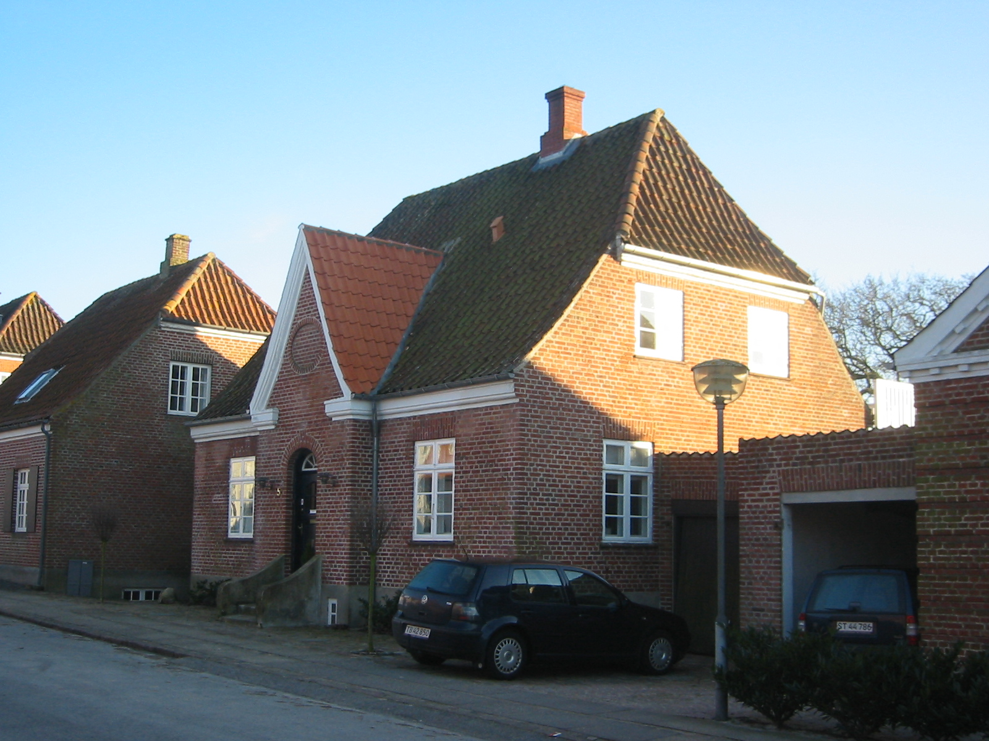

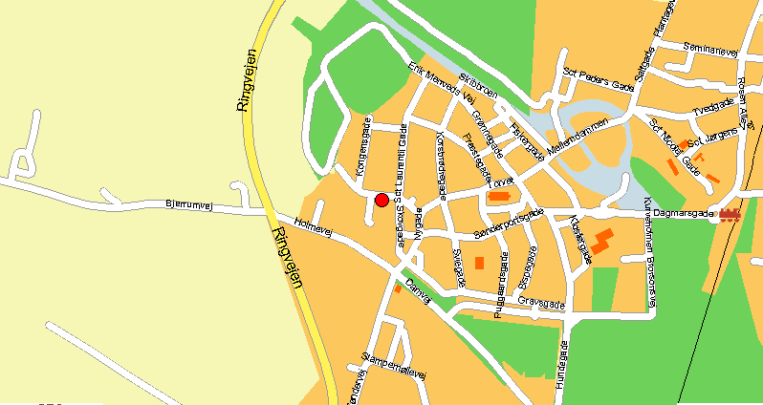

Alberts Bed and Breakfast is in the idyllic city of Ribe. It is in the old part of town in the center of Ribe. Enjoy the nice atmosphere in the area around the Cathedral.

Price: Doubleroom 400,00 kr. 55 €
Singleroom 300,00 kr. 41 €
1 Extra bed 100,00 kr. 13 €
Breakfast 50,00 kr. 7 €
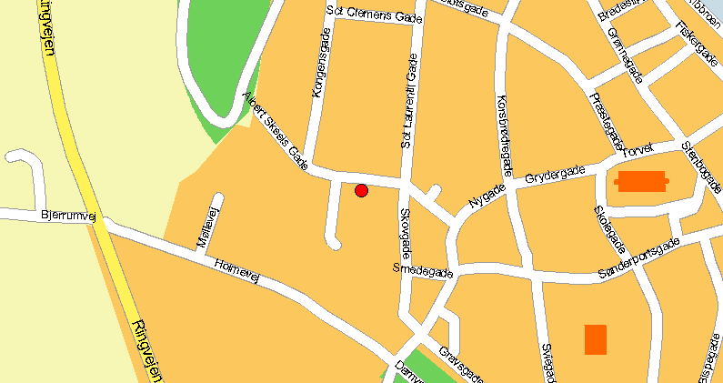
The price is incl. bedlinnen ad towels.

Earliest arrival 5.00 pm - latest departure 10.00 am or by agreementIf you are coming into town from the North you have to drive into the railway station. After this you go by Dagmarsgade and pass by the Cathedral, and then go by Grydergade. Turn right at Gråbrødretorv and then straight ahead until you get to Albert Skeels Gade.
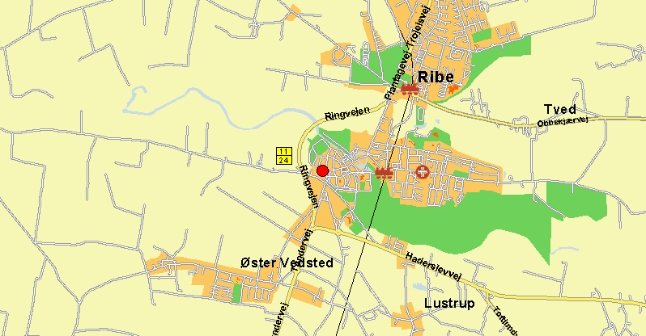
If you are coming in town from the South you have to go via Tøndervej to Haderslevvej. In the roundabout you turn left at Haulundvej. In the next roundabout you turn left at Stampemøllevej. Follow this road and then turn left at Gråbrødretorv and go straight ahead until you get to Albert Skeels Gade.

